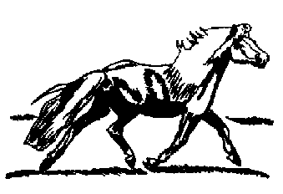

Grison Farm is please to Welcome Alabama CHF

Sire : Alpen Konig Dame: Blanka DOB: 1990 Inspected 78 Pts

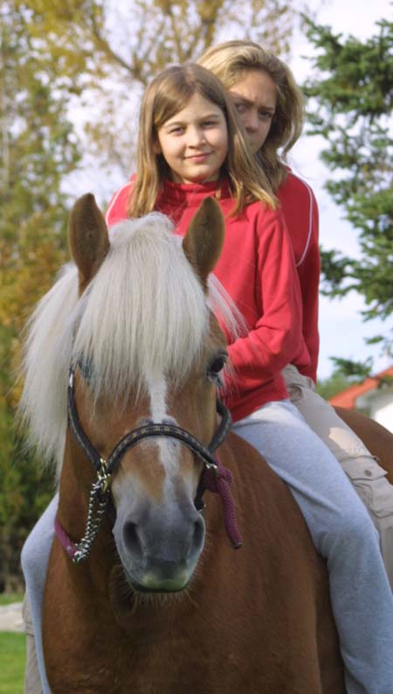
Alabama CHF

BREEDING AGREEMENT
2006 SERVICE FEE $ 650.00
+ Mare care

- 10 % If booked before January 1 2006

Live Cover Only & LIVE FOAL GUARANTEE*

2006 *Mare Care at $ 7.00 per day or $10.00 with Mare & foal

Your mare need a Coggins test showing negative results

Owner Name:___________________________________________________

Address :_______________________________________________________

Phone: _____________________________Fax:_______________________

Date that you plane to breed your mare?____________________________

Mare Name: _______________________________________Age:________

Registration #:____________Sire: ______________Dam:______________

I am including a $325.00 deposit
The balance ( $ 325.00 ) of the breeding fee will be send not later that August 2006

Signature : _________________________Date :__________

Grison Farm 126 Grande-Ligne, Racine Québec Canada J0E 1Y0

Call Theo : 450 532 4382 or 819 820 4626

